A.P.J. Abdul kalam
TAMIL NADU. 1931
ABDUL KALAM
RAMESWARAM. CHENNAI MAGANAM
TAMIL NADU.
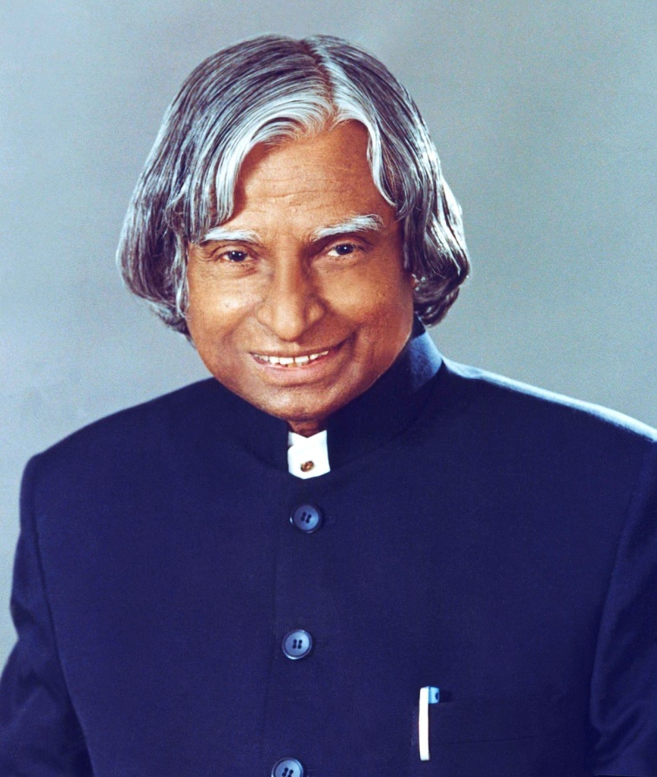
Born | 15 October 1931 Rameswaram. Madras presidency. British India (Present day Tamil Nadu,India)
Died | 27 July 2015 (aged 83) Shillong,Meghalaya,India
Resting place | Dr. A.P.J. Abdul Kalam Memorial. Rameswaram. Tamil Nadu. India
Party | Independent⁽¹⁾
Awards | Aerospace Scientist Author.

Born and raised in a Muslim family in Rameswaram . Tamil Nadu kalam studied physics and aerospace engineering. He spent the next four decades as a scientist and science administrator, mainly at the defence research and development organisation (DRDO) and Indian space research organisation (ISRO)and was intimately involved in India’s civilian space programme and military missile development efforts. He was known as the “Missile Man of India”for his work on the development of ballistic missile and launch vehicle technology. He also played a pivotal organisational , technical, and political role in pokhran-II nuclear tests in 1998. India’s second such test after the first test in 1974.

Dr. APJ Abdul kalam a well – know scientist, professor aeronautical engineer, the chanceller of the indian institute of space science amd technology (IIST), and the 11thpresident of india is one of the greatest personalities of our country.Honored by the highest civillan honour of india, bharat ratna and also called by the title like the missile man of india andf people president dr. APJ Abdul kalam is truly an inspiring personality.

